3.

(a) With the above definitions of p and q, what is the statement of the Function Independence Theorem, both symbolically and in words?

**p implies q**

**If the functions are independent on I then the determinant of the Wronskian is nonzero for some x0 ∈ I**

(b) With the above definitions of p and q, what is the contrapositive of the Function Independence Theorem, both symbolically and in words? (Be careful to correctly negate the “for some” statement in p.)

**~ q implies ~ p**

**If the vectors are dependent, then the determinant is zero. (Called the “contrapositive” of the “if” part of the theorem, it is equivalent to the original implication.)**

(c) What two statements (both symbolically and in words) are NOT necessarily true because of the Function Independence Theorem?

**If p implies q then q implies p**

**If ~p implies ~q then ~q implies ~p**

**If the functions are independent on I then the determinant of the Wronskian is nonzero for some x0 ∈ I**

**If the functions are dependent on I then the determinant of the Wronskian is zero for some x0 ∈ I**

(d) What statement (both symbolically and in words) would it make sense to call the “Converse Function Independence Theorem”?

**q implies p**

**If the functions are independent on I then the determinant of the Wronskian is nonzero for some x0 ∈ I**

4.

This is not the converse of the Function Independence Theorem. What is it? And why doesn’t that matter?

**This is the inverse function independence theorem, if you can disprove the negation of a statement then it disproves the original statement.**

5.

(a)



(b)

|  |  |  |  |
| --- | --- | --- | --- |
| *t* | ~~IT~~ | x(t) | y(t) |
| -3 | -1 | 0 | 18 |
| -2 | -1 | 0 | 8 |
| -1 | -1 | 0 | 2 |
| 0 | 0 | 0 | 0 |
| 1 | 1 | 2 | 0 |
| 2 | 1 | 8 | 0 |
| 3 | 1 | 18 | 0 |

(c)

**All of them are true according to the table above.**

(d)

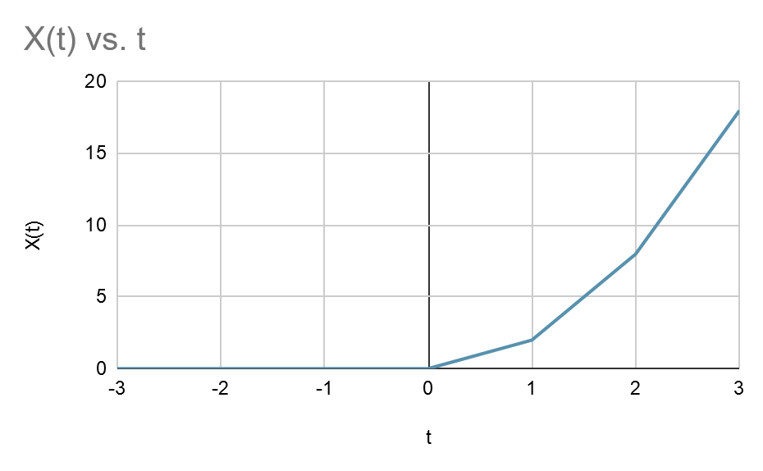

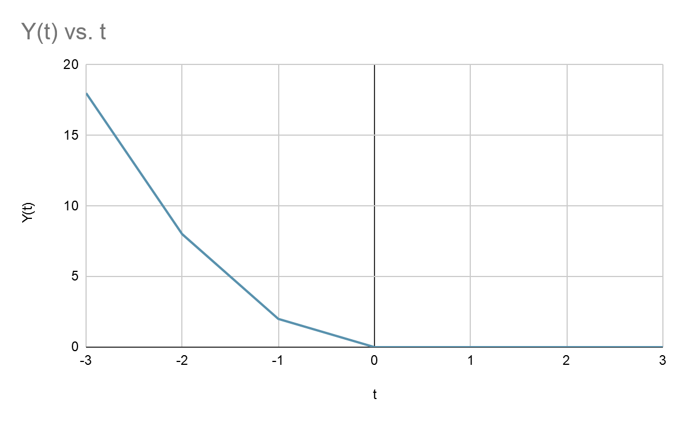

(e)

Lim t->0 @0, for x(t) and y(t)

(f)

|  |  |  |
| --- | --- | --- |
| 1 | 1 |  |
| -1 | -1 |  |

Det ^ = 0, therefore independence

(g)

|  |  |  |
| --- | --- | --- |
| t | W(x(t),y(t)) | det(W(x(t),y(t))) |
| -3 | |  |  | | --- | --- | | 0 | 18 | | 0 | 0 | | 0 |
| -2 | |  |  | | --- | --- | | 0 | 8 | | 0 | 0 | | 0 |
| -1 | |  |  | | --- | --- | | 0 | 2 | | 0 | 0 | | 0 |
| 0 | 0 | 0 |
| 1 | |  |  | | --- | --- | | 2 | 0 | | 0 | 0 | | 0 |
| 2 | |  |  | | --- | --- | | 8 | 0 | | 0 | 0 | | 0 |
| 3 | |  |  | | --- | --- | | 18 | 0 | | 0 | 0 | | 0 |
| t > 0 | |  |  | | --- | --- | | 2t^2 | 0 | | 4t | 0 | | 0 |

6.

(a)

If the wronskian det is not 0, this implies the functions are not linearly dependant.

(b)

The statement is always true, as a proof of the inverse is equivalent to the proof of the statement itself.

7.

(a)

|  |  |  |
| --- | --- | --- |
| *t* | X(t) | Y(t) |
| -3 | 9 | -9 |
| -2 | 4 | -4 |
| -1 | 1 | -1 |
| 0 | 0 | 0 |
| 1 | 1 | 1 |
| 2 | 4 | 4 |
| 3 | 9 | 9 |

(b)

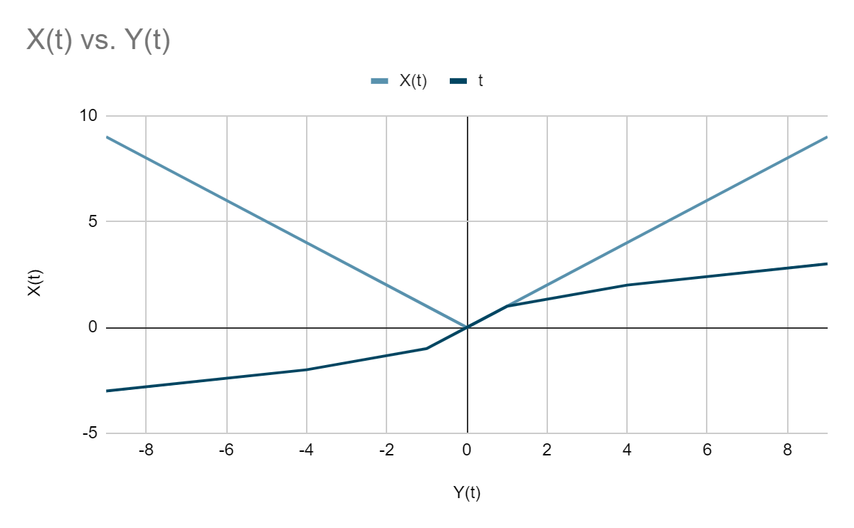

(c)

|  |  |  |  |  |
| --- | --- | --- | --- | --- |
| *t* | X(t) | Y(t) | X(t)+Y(t) | difference |
| -3 | 9 | -9 | 0 | 18 |
| -2 | 4 | -4 | 0 | 8 |
| -1 | 1 | -1 | 0 | 2 |
| 0 | 0 | 0 | 0 | 0 |
| 1 | 1 | 1 | 2 | 0 |
| 2 | 4 | 4 | 8 | 0 |
| 3 | 9 | 9 | 18 | 0 |

Comparing the table above to the table in task 5 shows that Peano’s statement is correct.

(d)

|  |  |  |
| --- | --- | --- |
| 1 | 1 |  |
| -1 | -1 |  |

(e)

8.

$u_{1}=e^{-1/x^{2}}(x≠0)$

$=0 (x=0)$

$u_{2}=e^{-1/x^{2}}(x>0)$

$=0 (x=0)$

$=2e^{-1/x^{2}}(x<0)$

$u_{1}'=e^{-1/x^{2}}*2/x^{3}(x≠0)$

$=0(x=0)$

$u_{2}'$ = $e^{-1/x^{2}}*2/x^{3}(x>0)$

$= 0 (x=0)$

= ${2e}^{-1/x^{2}}*2/x^{3}(x<0)$

And there is 3 cases when x=0

Wronskians = 0

When x>0;

${(e}^{-1/x^{2}}*$ $e^{-1/x^{2}}*2/x^{3})-{(e}^{-1/x^{2}}*e^{-1/x^{2}}*2/x^{3})=0$

when x<0:

${2e}^{-1/x^{2}}*2/x^{3}*e^{-1/x^{2}}-{2e}^{-1/x^{2}}*2/x^{3}*e^{-1/x^{2}}=0$

Because for all cases wronskians is zero so it is linearly independent.

9.

U1 =

{1+e^(-x^(-2)) , n != 0

{ 1 , n = 0

U2 =

{1+e^(-x^(-2)) , n != 0

{1 , n = 0

{1-e^(-x^(-2)) , n < 0

U3 = 1

10.

For $u_{1}$ and $u_{2}$ when x<0:

$u_{1}$ ≠ $u_{2}$ for all x, so it is linearly independent

For u1 and u3 when x!=0.

$u_{1}≠u_{3}$ for all x

For u2 and u3 when x!=0

$u_{2}≠u_{3}$ for all x

therefore they are linearly independent.